**- COURSE 08 -**

**- MODULE 1 : CAPSTONE BASICS -**

A capstone is a crowning achievement. In this part of the course, you’ll be introduced to capstone projects, case studies, and portfolios, and will learn how they help employers better understand your skills and capabilities. You’ll also have an opportunity to explore the online portfolios of real data analysts.

### **Learning Objectives**

* Identify the key features and attributes of a completed case study
* Differentiate between a capstone, case study, and a portfolio

INTRODUCTION TO THE CAPSTONE

[COURSE 8 OVERVIEW: SET YOUR EXPECTATIONS](https://www.coursera.org/learn/google-data-analytics-capstone/supplement/f9fgU/course-8-overview-set-your-expectations)

1. [Foundations: Data, Data, Everywhere](https://www.coursera.org/learn/foundations-data/home/welcome)
2. [Ask Questions to Make Data-Driven Decisions](https://www.coursera.org/learn/ask-questions-make-decisions/home/welcome)
3. [Prepare Data for Exploration](https://www.coursera.org/learn/data-preparation/home/welcome)
4. [Process Data from Dirty to Clean](https://www.coursera.org/learn/process-data/home/welcome)
5. [Analyze Data to Answer Questions](https://www.coursera.org/learn/analyze-data/home/welcome)
6. [Share Data Through the Art of Visualization](https://www.coursera.org/learn/visualize-data/home/welcome)
7. [Data Analysis with R Programming](https://www.coursera.org/learn/data-analysis-r/home/welcome)
8. **Google Data Analytics Capstone: Complete a Case Study** *(this course)*

You are approaching the last leg of your journey: the eighth and final course! You have gained the knowledge and job-ready skills to work as an entry-level data analyst. Through video vignettes, readings, journal entries, hands-on activities, online discussions, and networking with other learners, you now know what it takes to analyze and process data. You can find key insights and solve business problems using data.

To recap the highlights of your journey, you:

* Discovered data analysis, data analytics, and data ecosystems, and how data is used in organizational decision-making
* Learned how to ask SMART questions to make data-driven decisions, use spreadsheets, and work effectively with stakeholders
* Explored analytical thinking skills, the data analysis process, and the use of spreadsheets, SQL, and data visualizations as core data tools
* Practiced cleaning data in spreadsheets and SQL databases, and learned how important it is to verify, document, and report the cleaning process to ensure data integrity
* Organized, sorted, filtered, and aggregated data for analysis, and performed basic calculations with functions and formulas in spreadsheets, and SQL queries and temporary tables in databases
* Learned about design thinking, created visualizations and dashboards in Tableau, and worked on your communication skills to present engaging data-driven stories
* Wrote code in the R programming language to clean and analyze data, used RStudio to edit and run your code, and created detailed data visualizations in RStudio

## **What to expect**

The Google Data Analytics Certificate Capstone Project is an opportunity for you to use many of the skills and competencies you gained from earlier courses. You have already invested many weeks in the program, so completing this capstone project is like a grand celebration of your learning achievements! The Capstone Project is optional, and choosing whether or not to complete it will not affect your ability to receive your certificate. However, it is highly recommended! Completing the Capstone Project is a great way to put everything you’ve learned together and will be useful for future job applications.

What’s next? After you go over what capstone projects, case studies, and portfolios are, you will be presented with realistic cases. You will then choose one of them to use as your case study. Or, as an alternative, you can think of a case that aligns with your personal interests and use that for your case study. This will be your chance to actually go through the six steps of the data analysis process from start to finish. Use the links at the top of this page to review any content in other courses in the program to help you complete your case study.

Then, after you complete your case study, you can include it in your online portfolio. Your project will boost your confidence! You will be able to refer to it as an example of your work when you interview for data analyst positions. And finally, after you complete your project, you can use the final materials in this course to help you prepare for a job interview. Good luck, and enjoy working on your case study.

## **Course content**

Course 8 – Google Data Analytics Capstone: Complete a Case Study

1. **Capstone basics:** A capstone project in Coursera refers to a final project at the end of a study program. In the real world, these types of projects are more often referred to as case studies, Case studies are common ways for employers to assess the skills of prospective job candidates. In this part of the course, you will explore the benefits of using capstone projects, case studies, and portfolios to showcase your new skills to potential employers.
2. **Building your portfolio:** In this part of the course, you will be introduced to two tracks (and possible cases for you to use) to complete your capstone project. Depending on which track you choose, you will then be directed to specific lessons and instructions that are applicable to the track you selected. The final deliverable in either track is a finished case study for your online portfolio.
3. **Using your portfolio:** Having a case study in your portfolio is a first step. In this part of the course, you will focus on how you will use your portfolio to highlight skills that employers are looking for. You will develop an elevator pitch for your case study that enables people to quickly grasp a high-level understanding of what you did. Then, you can practice incorporating aspects of your case study into answers for different types of interview questions.

## **Course deliverables**

Your final deliverables will include the following:

* Completed case study
* Online portfolio
* Elevator pitch (for your case study)
* Updated LinkedIn profile

Your case study won’t be graded, but use all resources provided to help you successfully complete it. Participate in the [**Discussion Forums**](https://www.coursera.org/learn/google-data-analytics-capstone/discussions) for this course to chat with others who are working on the same or similar case studies. Strategies may be shared, but not specific analysis steps or activities. If you don’t already have an account, set up one on the platform you have chosen to host your portfolio. Practice your elevator pitch for your case study or share it with others to fine tune it.

## **Certificate requirements**

To qualify for the certificate, let us know if you've completed the optional case study (it's highly recommended) and pass all of the earlier required Course Challenges in the certificate with at least 80% correct answers. It’s certainly all right if you don’t pass a Course Challenge the first time you go through it. Before you try again, retake the practice quizzes to help you identify the topics you need to review. Then, go back to the videos and readings for those topics to better understand what you may have missed. You can take a Course Challenge up to three times to achieve a passing score.

You are on the path to getting your certificate soon!

**Updates to the course**

As you complete this course, you may notice updates to the content, like new practice materials and additional examples. These updates ensure the program provides up-to-date skills and guidance that will help you in your data analytics career. If you previously completed a graded activity, you *may* need to repeat the assessment in order to complete this course. For more information, check out [the course discussion forum.](https://www.coursera.org/learn/google-data-analytics-capstone/discussions)

[INTRODUCING THE CAPSTONE PROJECT](https://www.coursera.org/learn/google-data-analytics-capstone/lecture/vDmXA/introducing-the-capstone-project)

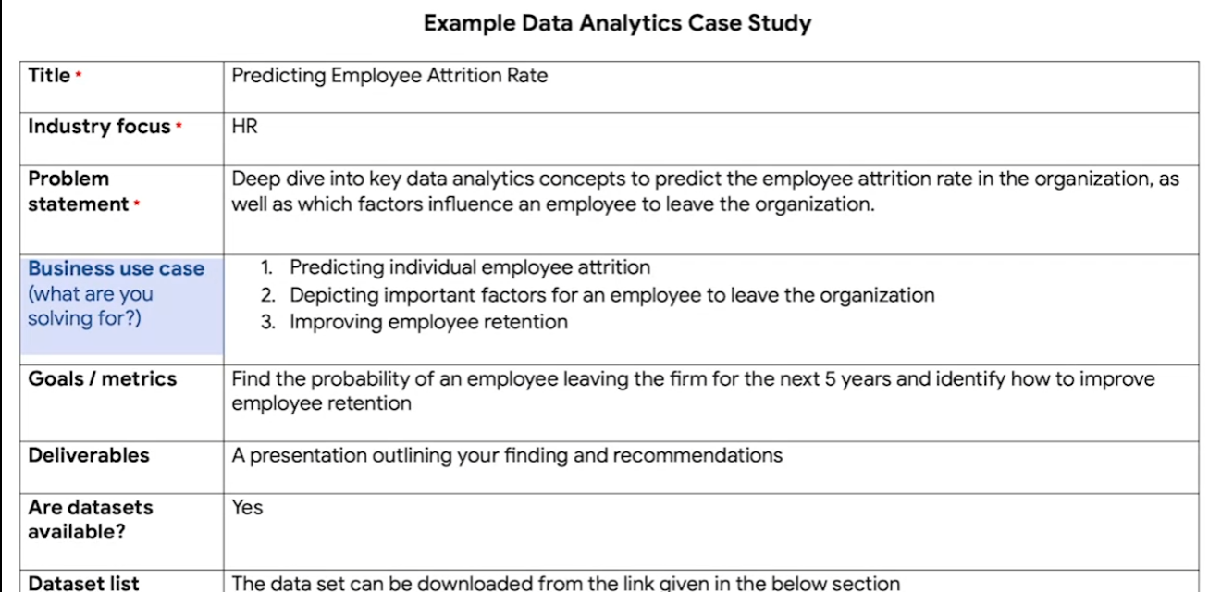

I'm so glad you're joining me for this last part of the program. This is an end-of- certificate project that Coursera and other learning platforms usually call a capstone.

The capstone brings everything you've learned together. You'll have the opportunity to take all of your new knowledge and put it into practice with a data analytics case study. In this video, we'll talk more about what that entails and how it can help you stand out during a job search. Case studies are practice data analytics projects.

When you're job hunting, you might be asked to do a case study after the pre-screen call or the first interview. The case study is a common way for employers to assess job skills and gain insight into how you approach common data-related challenges. Different employers might send you different kinds of case studies. For example, you might be asked to clean and analyze a data set, offer a proposal around how to measure the success of a project, or figure out and define metrics of success for a specific product. Usually, there's a time limit for the case study you've been asked to do.

For example, a potential employer might give you some sample data and project questions and ask you to create a presentation or memo with your recommendations in 24 to 48 hours. That time limit can be a little challenging. But the good news is, your answer to the case study doesn't have to be perfect. What's important is that you show off your thought process so that the interviewers can understand how you approach the problem. You can use the data analysis process we've learned throughout this program to guide you.

Let's check out an example and break down all of the parts. This case study has all of the information we'd need to perform this task.

It starts here, with the **title and the industry focus**: predicting employee attrition rate for human resources. It also includes a problem statement outlining what the overall goal is. In this case, they're asking for a deep dive into key data analytics concepts to predict the employee attrition rate in the organization, and which factors influence an employee to leave the organization.

Basically, this case study is interested in predicting the rate at which employees might leave the organization and why. There's some more specific goals in the next section. It's asking us to find the probability of an employee leaving the company over the next five years. That's pretty straightforward, but they're also interested in ways to improve employee retention.

This next section is really key. The **deliverables** are what we'll actually give them once we've completed the case study. In this example, they're asking for a presentation outlining our findings and recommendations.

Finally, they've included some **sections about the data** we'll use for this task. Here, it's a dataset that we can download.

Now we know more about case studies and how they might be presented to us in a job application process. But people who are passionate about data analytics will sometimes do case studies on their own time and add them to a personal portfolio.

A portfolio is a collection of case studies that can be shared with potential employers. Portfolios can be stored on public websites like GitHub, Kaggle, or Tableau, or on your blog. Your portfolio can also be linked in your resume. This will give you examples of how you approached data tasks in the past that you can talk about in your interview. These portfolios showcase your skills and help you stand out in job applications.

On top of the case study, we'll talk about building your portfolio and how to share it. This will be a great building block that you can use to build up your resume. Coming up, we'll check out some great examples of case studies and portfolios that will hopefully inspire you as you start your own.

[EXPLORE PORTFOLIOS](https://www.coursera.org/learn/google-data-analytics-capstone/supplement/umI9H/explore-portfolios)

Earlier, you learned that a portfolio contains samples that you share with potential employers. Case studies are practice or example data analytics projects that you can create for your portfolio. After you have created your online portfolio, you can add a link to it on your resume. Having a portfolio to showcase who you are and demonstrate your skills will help you stand out to potential employers. The case study that you will complete in this course can be one of the examples that you add to your portfolio.



In this reading, you will learn some important things to keep in mind when building your portfolio. You will also explore GitHub and Kaggle, which are platforms that can host your portfolio. You will view the professional profiles of two data analysts and what they include in their portfolios on Kaggle.

# **Ins and outs of building your portfolio**

First and foremost, your portfolio should represent your *own* work. While getting ideas from other portfolios is inspiring, directly copying (or only slightly modifying) others’ work and sharing it in your own portfolio is never acceptable.

Additionally, if you work on a project as a data analyst, keep in mind that the work you do for an employer or client belongs to their business. In many cases, you can’t share that work publicly in your personal portfolio without direct and explicit permission from them beforehand.



Finally, be cautious even with open or public datasets. Unless you are using data that you personally collected, ask the owner of the data for permission before you post anything related to the data in your portfolio. You should always take full responsibility for what you publish by getting the right permissions as needed.

As you begin to develop your portfolio, there are a few considerations you can use to help you decide how best to incorporate your work:

* **Choose your projects**: Select projects that resonate with your skills and career goals. Your portfolio should reflect a range of skills that connect directly to the work you would be doing as a data analytics professional.
* **Capture your process**: When discussing projects with potential employers, it’s more useful to focus on your process than on your results. Describe your strategies; discuss the tools you used; and explain the decisions you made along the way, as well as why you made them. This insight gives potential employers a glimpse into your problem-solving abilities and thought processes.
* **Aesthetics matter**: Your portfolio should be easy to navigate and visually appealing. Professionalism, simplicity, and engagement are key.
* **Tell your story:** Clearly explain the background of each project. What challenges did you face? What steps did you take to overcome them? And what impact did your work have? Consider all of the people who you are communicating with. Who are they and what do they need to know about you?

Now, let’s review three platforms you can use to host your portfolio.

## **Personal websites**

Creating a **personal website** to host your portfolio is a great option because you can also use it to showcase aspects of your personality or background that contribute to your professional brand. For example, you might share a compelling experience that reflects your ability to collaborate, be resilient, or not give up. Whatever you choose to share, make sure that it is something you wouldn’t mind other people knowing about you.

For example, this visualization from data analyst [Bill Yost’s website](https://www.billyost.net/) demonstrates his ability to create a Tableau visualization but also tells a very personal story about his battle with cancer. Potential employers get an idea of his skills and find out a lot more about who he is at the same time.

Notice that although the annotations in the visualization appear somewhat crowded in the white space (per guidelines in the [Share Data Through the Art of Visualization](https://www.coursera.org/learn/visualize-data/supplement/ewNyk/pro-tips-for-headlines-subtitles-and-labels) course), the concept of sharing a personal story is the main takeaway.

## **GitHub**

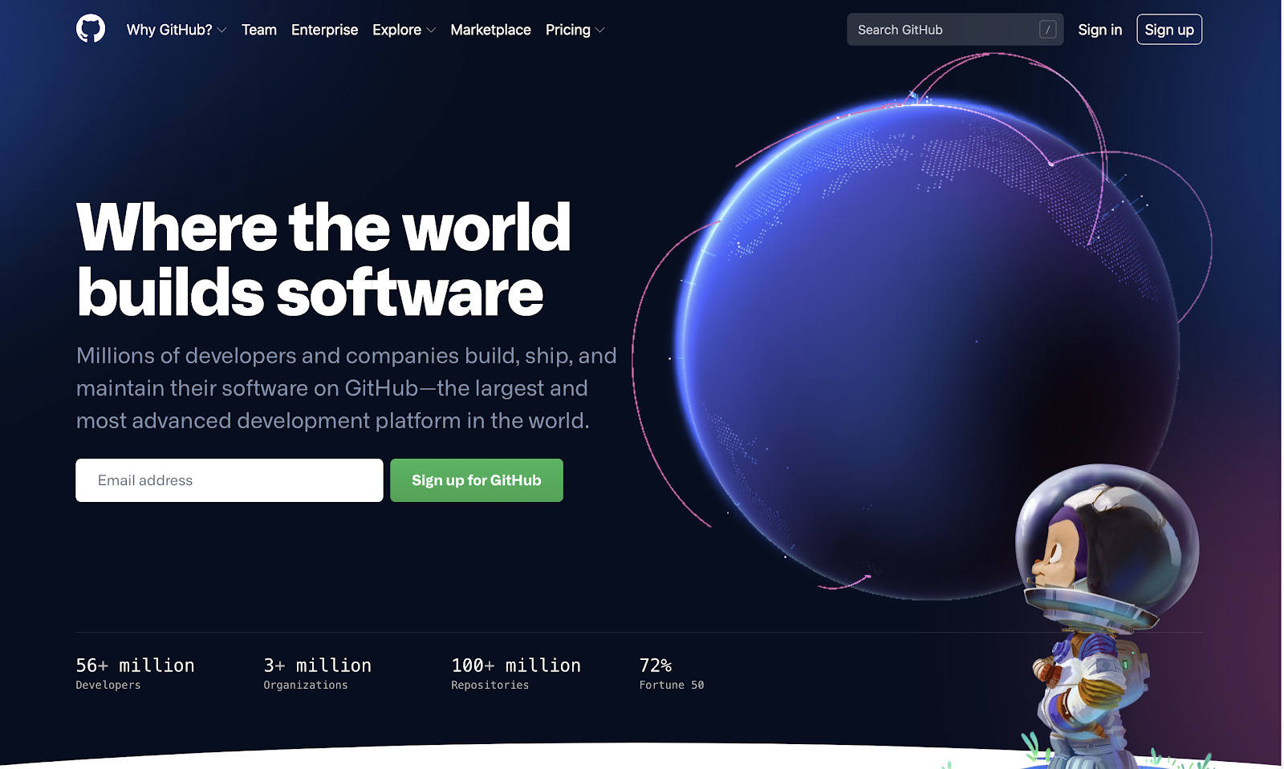

**GitHub** is a hosted platform primarily used by developers as a repository for code, but it can also be used as a repository for documentation. One of the tips you have been given in this program is to keep an electronic journal of things to remember, especially for SQL or R syntax. If something in your electronic journal is particularly useful, you can create a document for your portfolio in GitHub. For inspiration, check out this [R usage tips](https://github.com/erikaduan/R-tips/blob/master/README.md) readme document a GitHub user posted.

## **Kaggle**

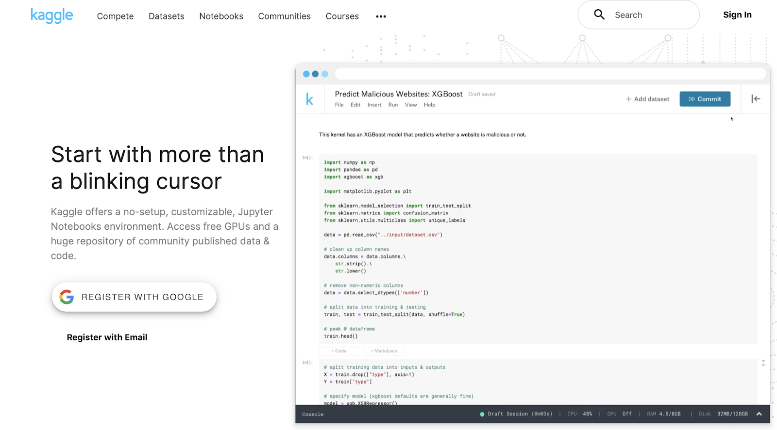

If you have an account on **Kaggle**, you can also use it as a platform to host your portfolio and personal background. Check out these profile examples:

* [Jesse Mostipak's profile](https://www.kaggle.com/jessemostipak)
* [Meg Risdal's profile](https://www.kaggle.com/mrisdal)

Their profiles showcase competitions they have participated in, datasets they have created, and discussions they have contributed to. Kaggle **competitions** are challenges that people take on at any stage of their programming and machine learning careers. Check out this YouTube video to learn [how to enter a Kaggle competition](https://www.youtube.com/watch?v=GJBOMWpLpTQ). Both Jesse’s and Meg’s profiles also include links to follow them on other social media platforms, like LinkedIn and Twitter.

**Jupyter Notebook** is an open-source web application that you can use to create and share documents that contain live code, equations, visualizations, and narrative text. Kaggle supports a Jupyter Notebook environment that can be accessed from a browser. Jesse and Meg also have notebooks in Kaggle. You can use Kaggle to create your own notebooks for potential employers to view.

* Click [Jesse Mostipak's Code link](https://www.kaggle.com/jessemostipak/code) to view her public notebooks
* Click [Meg Risdal's Code link](https://www.kaggle.com/mrisdal/code) to view her public notebooks

[DATA JOURNAL: PREPARE FOR YOUR PROJECT](https://www.coursera.org/learn/google-data-analytics-capstone/quiz/oNWJe/data-journal-prepare-for-your-project)

[RISHIE: WHAT EMPLOYERS LOOK FOR IN DATA ANALYSTS](https://www.coursera.org/learn/google-data-analytics-capstone/lecture/wsFXf/rishie-what-employers-look-for-in-data-analysts)

[INTRODUCE YOURSELF](https://www.coursera.org/learn/google-data-analytics-capstone/discussionPrompt/boH9Q/introduce-yourself)

SAMPLE CASES FOR DATA PROFESSIONALS

[BEST-IN-CLASS](https://www.coursera.org/learn/google-data-analytics-capstone/lecture/GQVN8/best-in-class)

[YOUR PORTFOLIO AND CASE STUDY CHECKLIST](https://www.coursera.org/learn/google-data-analytics-capstone/supplement/J4RDY/your-portfolio-and-case-study-checklist)

[REVISIT CAREER PATHS IN DATA](https://www.coursera.org/learn/google-data-analytics-capstone/supplement/g8ypL/revisit-career-paths-in-data)

[NEXT STEPS](https://www.coursera.org/learn/google-data-analytics-capstone/supplement/f3jEs/next-steps)

**- MODULE 2 : BUILD YOUR PORTFOLIO -**

In this part of the course, you’ll review two possible tracks to complete your case study. You can use a dataset from one of the business cases provided or search for a public dataset to develop a business case for an area of personal interest. In addition, you'll be introduced to several platforms for hosting your completed case study.

### 

### **Learning Objectives**

* Apply the practices and procedures associated with the data analysis process to a given set of data.
* Discuss the expectations involved in completing a data analysis case study.
* Move their portfolio to Kaggle, post and make it public
* Add R Code to a Kaggle Notebooks
* Recall the different types of Kaggle Notebooks

GET STARTED

[INTRODUCTION TO BUILDING YOUR PORTFOLIO](https://www.coursera.org/learn/google-data-analytics-capstone/supplement/NNGNj/introduction-to-building-your-portfolio)

[GET STARTED WITH YOUR CASE STUDY](https://www.coursera.org/learn/google-data-analytics-capstone/lecture/AOqWB/get-started-with-your-case-study)

[CHOOSE YOUR CASE STUDY TRACK](https://www.coursera.org/learn/google-data-analytics-capstone/supplement/NTV8r/choose-your-case-study-track)

[CAPSTONE ROADMAP](https://www.coursera.org/learn/google-data-analytics-capstone/ungradedWidget/8j3Hf/capstone-roadmap)

**CASE STUDY TRACK A** **:** WORK WITH EXISTING QUESTIONS AND DATASETS

[TRACK A DETAILS](https://www.coursera.org/learn/google-data-analytics-capstone/supplement/bY66y/track-a-details)

[CASE STUDY 1: HOW DOES A BIKE-SHARE NAVIGATE SPEEDY SUCCESS?](https://www.coursera.org/learn/google-data-analytics-capstone/supplement/7PGIT/case-study-1-how-does-a-bike-share-navigate-speedy-success)

[CASE STUDY 2: HOW CAN A WELLNESS COMPANY PLAY IT SMART?](https://www.coursera.org/learn/google-data-analytics-capstone/supplement/ZsmDD/case-study-2-how-can-a-wellness-company-play-it-smart)

[CASE STUDY 1: HOW DOES A BIKE-SHARE NAVIGATE SPEEDY SUCCESS?](https://www.coursera.org/learn/google-data-analytics-capstone/discussionPrompt/3f0B9/case-study-1-how-does-a-bike-share-navigate-speedy-success)

[CASE STUDY 2: HOW CAN A WELLNESS COMPANY PLAY IT SMART?](https://www.coursera.org/learn/google-data-analytics-capstone/discussionPrompt/BQyYm/case-study-2-how-can-a-wellness-company-play-it-smart)

**CASE STUDY TRACK B :** CHOOSE YOUR OWN QUESTIONS AND DATASETS

[TRACK B DETAILS](https://www.coursera.org/learn/google-data-analytics-capstone/supplement/zbwbs/track-b-details)

[CASE STUDY 3: FOLLOW YOUR OWN CASE STUDY PATH](https://www.coursera.org/learn/google-data-analytics-capstone/supplement/vcS93/case-study-3-follow-your-own-case-study-path)

[RESOURCES TO EXPLORE OTHER CASE STUDIES](https://www.coursera.org/learn/google-data-analytics-capstone/supplement/ZQGDM/resources-to-explore-other-case-studies)

[CASE STUDY 3: FOLLOW YOUR OWN CASE STUDY PATH](https://www.coursera.org/learn/google-data-analytics-capstone/discussionPrompt/2RsQw/case-study-3-follow-your-own-case-study-path)

SHARE YOUR CASE STUDY AND PORTFOLIO

[UNLIMITED POTENTIAL WITH ANALYTICS CASE STUDIES](https://www.coursera.org/learn/google-data-analytics-capstone/lecture/bQG93/unlimited-potential-with-analytics-case-studies)

[SHARE YOUR PORTFOLIO](https://www.coursera.org/learn/google-data-analytics-capstone/lecture/PaZYY/share-your-portfolio)

[CREATE YOUR ONLINE PORTFOLIO](https://www.coursera.org/learn/google-data-analytics-capstone/supplement/m86c7/create-your-online-portfolio)

[HANDS-ON ACTIVITY: ADD YOUR PORTFOLIO TO KAGGLE](https://www.coursera.org/learn/google-data-analytics-capstone/quiz/Ovp6u/hands-on-activity-add-your-portfolio-to-kaggle)

[OPTIONAL: SHARE YOUR PORTFOLIO WITH OTHERS](https://www.coursera.org/learn/google-data-analytics-capstone/discussionPrompt/Y2d8m/optional-share-your-portfolio-with-others)

**- MODULE 3 : USE YOUR PORTFOLIO -**

Your portfolio is meant to be seen and explored. In this part of the course, you’ll learn how to discuss your portfolio and highlight specific skills in interview scenarios. You’ll also create and practice an elevator pitch for your case study. Finally, you’ll discover how to position yourself as a top applicant for data analyst jobs with useful and practical interview tips.

### **Learning Objectives**

* Discuss the benefits and uses of case studies and portfolios in the job search.
* Discuss the use of case studies and portfolios when communicating with recruiters and potential employers.

SHARE YOUR WORK WITH RECRUITERS

[INTRODUCTION TO SHARING YOUR WORK](https://www.coursera.org/learn/google-data-analytics-capstone/supplement/oYSz8/introduction-to-sharing-your-work)

[DISCUSSING YOUR PORTFOLIO](https://www.coursera.org/learn/google-data-analytics-capstone/lecture/BBZ2K/discussing-your-portfolio)

[SELF-REFLECTION: POLISH YOUR PORTFOLIO](https://www.coursera.org/learn/google-data-analytics-capstone/quiz/Ct0Ct/self-reflection-polish-your-portfolio)

IN THE INTERVIEW

[THE INTERVIEW PROCESS](https://www.coursera.org/learn/google-data-analytics-capstone/supplement/EcvV9/the-interview-process)

[SCENARIO VIDEO SERIES INTRODUCTION](https://www.coursera.org/learn/google-data-analytics-capstone/supplement/EwEjY/scenario-video-series-introduction)

[SCENARIO VIDEO: INTRODUCTIONS](https://www.coursera.org/learn/google-data-analytics-capstone/lecture/wrtl6/scenario-video-introductions)

[WHAT MAKES A GREAT PITCH](https://www.coursera.org/learn/google-data-analytics-capstone/supplement/y5U2D/what-makes-a-great-pitch)

[SCENARIO VIDEO: CASE STUDY](https://www.coursera.org/learn/google-data-analytics-capstone/lecture/QVEOb/scenario-video-case-study)

[SCENARIO VIDEO: PROBLEM-SOLVING](https://www.coursera.org/learn/google-data-analytics-capstone/lecture/Vzxva/scenario-video-problem-solving)

[TOP TIPS FOR INTERVIEW SUCCESS](https://www.coursera.org/learn/google-data-analytics-capstone/supplement/YXCEi/top-tips-for-interview-success)

[PREPARE FOR INTERVIEWS WITH INTERVIEW WARMUP](https://www.coursera.org/learn/google-data-analytics-capstone/supplement/OADbB/prepare-for-interviews-with-interview-warmup)

BEFORE YOU ACCEPT

[NEGOTIATE YOUR CONTRACT](https://www.coursera.org/learn/google-data-analytics-capstone/supplement/6SYNp/negotiate-your-contract)

[SCENARIO VIDEO: NEGOTIATING TERMS](https://www.coursera.org/learn/google-data-analytics-capstone/lecture/MS5NP/scenario-video-negotiating-terms)

[NATHAN: VETNET AND GIVING ADVICE TO VETS](https://www.coursera.org/learn/google-data-analytics-capstone/lecture/DwcYp/nathan-vetnet-and-giving-advice-to-vets)

**- MODULE 4 : PUT YOUR CERTIFICATE TO WORK -**

Earning your Google Data Analytics Certificate is a badge of honor. It's also a real badge. In this part of the course, you'll learn how to claim your certificate badge and display it in your LinkedIn profile. You'll also be introduced to job search benefits that you can claim as a certificate holder, including access to the Big Interview platform and Byteboard interviews.

### **Learning Objectives**

* Identify key software applications critical to the work of a data analyst including reference to spreadsheets, databases, query languages, and visualization tools (applications).
* Follow the steps to register for the Big Interview platform
* Describe how to sign up and take a Byteboard interview
* Understand how to claim your Google Data Analytics Certificate badge

PROGRAM WRAP-UP

[DID YOU COMPLETE A CASE STUDY?](https://www.coursera.org/learn/google-data-analytics-capstone/exam/FTPzN/did-you-complete-a-case-study)

[CONGRATULATIONS ON COMPLETING YOUR CAPSTONE PROJECT!](https://www.coursera.org/learn/google-data-analytics-capstone/lecture/f3omO/congratulations-on-completing-your-capstone-project)

[CONNECT WITH GOOGLE DATA ANALYTICS CERTIFICATE GRADUATES](https://www.coursera.org/learn/google-data-analytics-capstone/discussionPrompt/Uw9dp/connect-with-google-data-analytics-certificate-graduates)

[SHOWCASE YOUR WORK](https://www.coursera.org/learn/google-data-analytics-capstone/supplement/WwBuw/showcase-your-work)

[CLAIM YOUR GOOGLE DATA ANALYTICS CERTIFICATE BADGE](https://www.coursera.org/learn/google-data-analytics-capstone/supplement/Cguh4/claim-your-google-data-analytics-certificate-badge)

[SIGN UP TO THE BIG INTERVIEW PLATFORM](https://www.coursera.org/learn/google-data-analytics-capstone/supplement/NVv29/sign-up-to-the-big-interview-platform)

[FROM ALL OF US ...](https://www.coursera.org/learn/google-data-analytics-capstone/lecture/k08OP/from-all-of-us)

[END-OF-PROGRAM SURVEY](https://www.coursera.org/learn/google-data-analytics-capstone/ungradedWidget/I2LiX/end-of-program-survey)

[EXPLORE PROFESSIONAL OPPORTUNITIES](https://www.coursera.org/learn/google-data-analytics-capstone/lecture/AsRWZ/explore-professional-opportunities)

[EXPAND YOUR DATA CAREER EXPERTISE](https://www.coursera.org/learn/google-data-analytics-capstone/supplement/vSVdo/expand-your-data-career-expertise)

[END-OF-CERTIFICATE CHECKLIST](https://www.coursera.org/learn/google-data-analytics-capstone/quiz/bBMCt/end-of-certificate-checklist)

AI FOR DATA ANALYTICS

[INTRODUCTION TO AI FOR DATA ANALYTICS](https://www.coursera.org/learn/google-data-analytics-capstone/supplement/tbCmy/introduction-to-ai-for-data-analytics)

[AI TOOLS FOR DATA ANALYTICS](https://www.coursera.org/learn/google-data-analytics-capstone/supplement/QBiY0/ai-tools-for-data-analytics)

[GENERATIVE AI IN DATA ANALYTICS: PRACTICAL APPLICATIONS](https://www.coursera.org/learn/google-data-analytics-capstone/supplement/yExgD/generative-ai-in-data-analytics-practical-applications)

[ACTIVITY: EXPLORE DATA VISUALIZATIONS WITH AI](https://www.coursera.org/learn/google-data-analytics-capstone/assignment-submission/EVSnn/activity-explore-data-visualizations-with-ai)

[KEY TAKEAWAYS FROM AI FOR DATA ANALYTICS](https://www.coursera.org/learn/google-data-analytics-capstone/supplement/jvhnW/key-takeaways-from-ai-for-data-analytics)

[INTRODUCING GOOGLE AI ESSENTIALS](https://www.coursera.org/learn/google-data-analytics-capstone/lecture/u0ApF/introducing-google-ai-essentials)

[TAKE THE NEXT STEP WITH GOOGLE AI ESSENTIALS](https://www.coursera.org/learn/google-data-analytics-capstone/supplement/xa2Kd/take-the-next-step-with-google-ai-essentials)